  L1 FA24

Q1:

Software Requirements Specification

for

FU Exam360

Version 1.0 approved

Prepared by

Trần Ngọc Khiết – SE192015

FPT University HCM Campus

Jul-27, 2025

Q2:

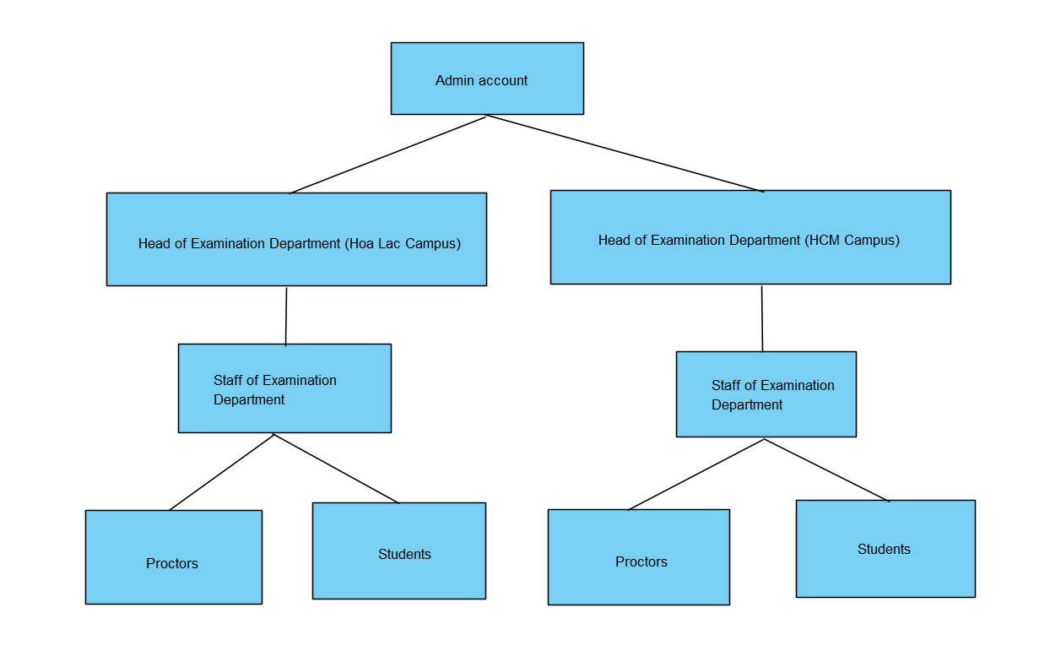

Type of user of the website in this system has the largest number is Stundents.

Q3:

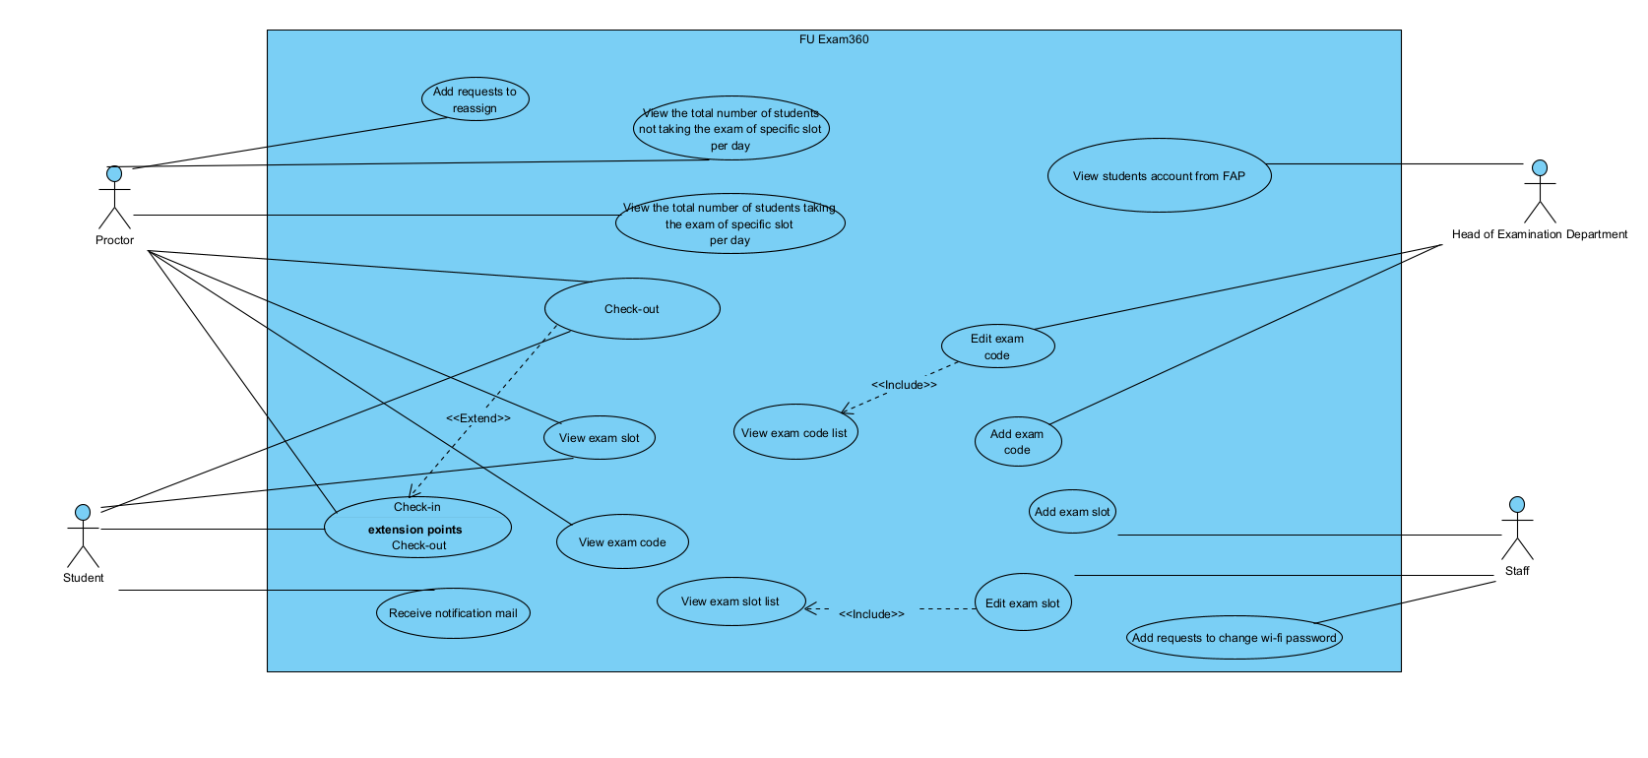

1. In this exam paper, the name of the rectangle is: FU Exam360  
2. The actor may be human, other software systems, or devices. In this exam paper, list the name of >= 4 actors is: Head of Examination Department, Staff, Students, Proctors  
3. In this exam paper, list the name of >= 5 use cases are: check-in, check-out,  
list exam slot, add exam slot, edit exam slot  
4. The actors are inside or outside of the rectangle? outside  
5. The ovals represent the use cases are inside or outside of the rectangle? inside  
6. The primary actor of the use case Add Exam Slot is: Staff  
7. The secondary actor of the use case Add Exam Slot is: Proctor, Student  
8. Based on the fact that you have already used the FUE Exam360 website, the use cases in this electronic exam paper may have a relationship.  
 a) List the name of two use cases that have an extend relationship: check-in, check-out  
 b) The name of the base use case (in 8.a) is: check-in  
 c) The name of the extend use case (in 8.a) is: check-out  
 d) The dashed line with an arrow that points to which use case? check-in   
9. Based on the fact that you have already used the FUE Exam360 website, the use cases in this electronic exam paper may have a relationship.  
 a) List the name of two use cases that have an include relationship: view list exam code, edit exam code  
 b) The name of the base use case (in 9.a) is: edit exam code  
 c) The name of the included use case (in 9.a) is: view list exam code  
 d) The dashed line with an arrow that points to which use case? view list exam code

Q4:

< Student must replace this line, answer of Q4 by filling the content into the below table that reflects this exam paper. NOTE: Student must remove the guideline in and after the (….).>

|  |  |  |  |
| --- | --- | --- | --- |
| UC ID and Name: | UC – 1 Add exam slot | | |
| Created By: | tranngockhiet22062005@gmail.com. | Date Created: | Jul-23, 2025 |
| Primary Actor: | Staff | Secondary Actors: | Student, Proctor |
| Trigger: | Staff click the “Add exam slot” button | | |
| Description: | Staff indicates the disire to to add an exam slot.   * Staff choose to add multiple exam slots. * Staff to choose to add a specific slot in a date. | | |
| Preconditions: | 1. User has logged in with right authentication 2. User has been authorized to add exam slot | | |
| Post conditions: | 1. Display the exam slot(s) in the screen. 2. Student, Proctor see the exam slot. | | |
| Normal Flow: | 1. Staff click the “Add exam slot” button. 2. System displays a form to fill in information. 3. Staff fills in information. 4. System display the list of student to choose for the exam slot. 5. Staff choose students to add to exam slot and click confirm adding. 6. System display a message to indicate add successfully. | | |
| Alternative Flows: | 1.1 System ask if Staff want to create multiple exam slots.  1.2 Staff choose to add multiple exam slots.  1.3 System asks for number of slots to be created.  1.4 Staff choose a number of slots  1.5 Back to step 1 | | |
| Exceptions: | 5.1 Staff choose a students that has been assigned to a slot at the same time.  5.2 System display a message to indicate that the student has been assign to the same slot time.  5.3 Back to step 5.  3.1 Staff fill in a date in the past.  3.2 System display a message to indicate that can not choose a time in the past.  3.3 Back to step 3. | | |
| Priority: | High | | |
| Frequency of Use: | 75 times per month | | |
| Business Rules: | BR-1: All information about the exam slot must be fullfill.  BR-2: Staff can cancel the add exam slot at anytime prior than confirming. | | |
| Other Information: | * The api for this function is /api/exam-management/exam-schedule/add-new * Form data must retain in the website even if user lost internet connection and should be display to user after reconnect. | | |
| Assumptions: | * User has [fpt@edu.vn](mailto:fpt@edu.vn) email to login | | |

**Q5:**

1. NFR-1: System should operate normally under high load (like in class hour or exam hour)

Explaination: Tester simulates 2000 concurent user to use the system at the same time, if the response time under 3 second, then the test passes.

NFR-2: Staff should receive the re-assign request fast so that student can do the exam in time if they have any problem while taking the exam.

Explaination: Tester simulate to send 200 re-asssign requests at the same, if Staff receive the requests under 2 seconds, then the test passes.

NFR-3: Many staff should be able to create multiple exam slots add a time

Explaination: Tester simulate to send 3000 create exam slot request at the same time, if the response time under 3 second, then the test passes.

NFR-4: The user should be auto log out after 60 minute session.

Explaination: Tester log in the system and wait for 60 minute session time out, then choose a menu function to use, if the account log outm, then the test passes.